Name: | Period: | Date:
Foundations of Technology
First Five Days
File 5.1: Creativity and Brainstorming Activity
Background
To be a great designer, problem solver, inventor, or innovator, one must be able to think outside the norm. To think differently than most is considered creative thinking. Imagine, if we were all to think exactly in the same manner, there would be no new ideas, inventions, or innovations because we would already have thought of them. To be a creative genius, one does not need to be have a perfect SAT score, but must be able to think “outside the box.” There are several techniques to aid in the ability to brainstorm and design solutions that are unique and creative.

This activity is to allow you to practice techniques in creative brainstorming while redesigning a plain little car so that consumers will want to purchase it.


Hybrid-powered cars, MP3 players, mobile phones, laptop computers, and video games are just a few products with which most of us are familiar. Think about one of these products—what is it that you like about it? What makes you to want to buy a computer or an MP3 player? Is it the television commercials, or is it the appearance of the product? Whatever the reason, design plays a vital role in the creation and marketing of any product.

Procedure
This assignment is designed to provide an exercise of using the design process and creativity techniques. You will creatively brainstorm ways to enhance or change a plain little car so that consumers will want to purchase it. Remember to apply the rules for brainstorming that were identified in the PowerPoint prior to this activity. You must also use the techniques of creativity that we have discussed.

Complete the following in your engineering journal:
- 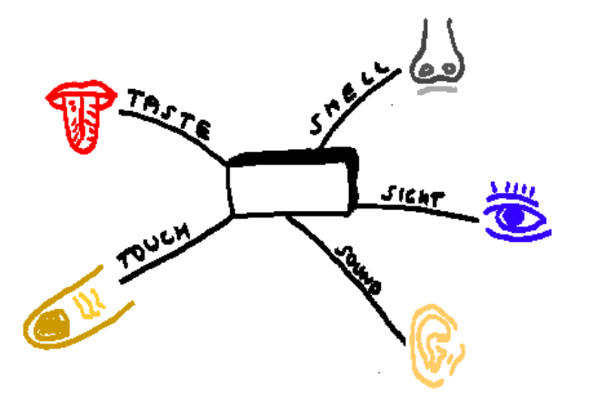Review the brainstorming rules.
- Review the creative techniques.
- Begin mind mapping with the given template. The template will help you start to think outside the norm.
- Utilize the inventive problem-solving process and the
da Vinci Method.
- Sketch your dashboard design and layout in your journal.
- Label all the parts.
- Be creative, be inventive, think outside the box, and have fun.

